Let’s talk about food habits !
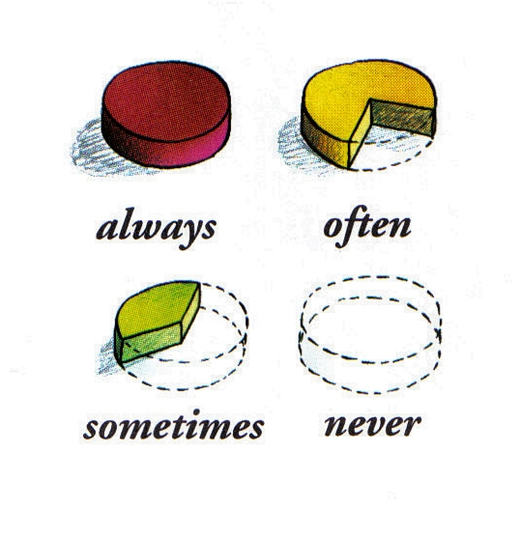

A/ What are your food habits ? (interview other pupils)

Questions | Answers
Do you always have a breakfast ? | Yes, I always do.  Yes, I often do.  Yes, I sometimes do.
Do you often eat… ? | Yes, I always do.  Yes, I often do.  Yes, I sometimes do.
Do you often eat… ? | No I never do.  No, I don’t.
Do you sometimes drink…. ? | No I never do.  No, I don’t.

B/ What are his/her food habits ? (tell about other pupils)
Questions | Answers
Does she/he always have a breakfast ? | Yes, she/he always does.  Yes, she/he often does.  Yes, she/he sometimes does.
Does he/she often eat… ?
Does he/she often eat… ? | No she/he never does.  No, She/he doesn’t.
Does she/he sometimes drink…. ? | No she/he never does.  No, She/he doesn’t.

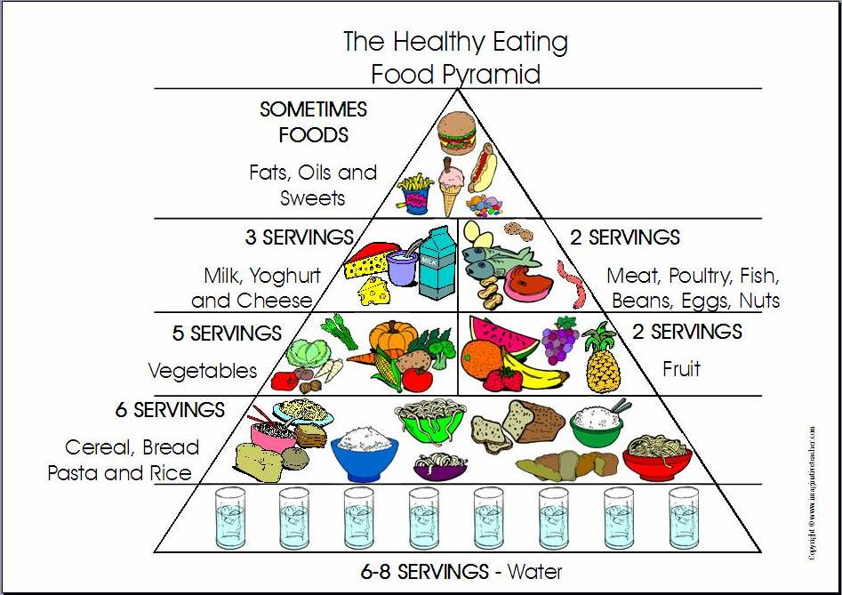
What is healthy* to eat or drink ? …………………………………………………………………………………………………
What is not healthy* to eat or drinK ?
…………………………………………………………………………………………………
(*healthy = good for you and your body)

